**Exp No - 12 Implement Cursors**

**create table login(username varchar(10) primary key, passwd varchar(10));**

**insert into login values("username", "password");**

**select * from login;**

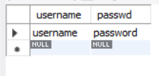

**delimiter //**

**CREATE PROCEDURE test()**

**BEGIN**

**DECLARE i TEXT;**

**DECLARE n TEXT;**

**DECLARE curs1 CURSOR FOR SELECT username,passwd FROM login;**

**OPEN curs1;**

**FETCH curs1 INTO i,n;**

**SELECT i,n;**

**CLOSE curs1;**

**END//**

**call test()//**

